**Name and surname:** Tetyana Pimonenko

**Age:** 35 years

**Gender:** female

**The sending university:** Sumy State University, Ukraine

**Country of Mobility:** Latvia

**Host university**: EKA University of Applied Sciences, Pernavas iela 62, Riga, LV-1009, Latvia

**Field of study:** Economics

**Duration of the mobility period:** April 18-24, 2023

**The purpose of the mobility** was to participate in the International Academic Week 2023 (IAW 2023) at EKA University of Applied Sciences and deliver a lecture on "Bibliometric analysis: instruments and core stages, principles and instruments."

**During the mobility**, I engaged in preliminary negotiations with Renata Skypalova from Ambis Vysoka skola in the Czech Republic and Anotolijs Prohorovs from RIESBA University of Applied Sciences.

The mobility program was packed with a diverse range of lectures, trainings, and workshops, including topics such as the nexus of business and art in research and entrepreneurship, storytelling and gamification in cultural events and marketing, and different art techniques in educational processes.

The mobility program **allowed for**:

* Enhancing the exchange of scientific experience to find perspectives for cooperation in research and future grant projects.
* Acquiring and exchanging academic experience.
* Establishing cooperation in research on economic issues.
* Studying effective ways to develop international activity and innovative teaching methods used at EKA University of Applied Sciences.
* Disseminating best practices of participation in Associations.
* Sharing knowledge on Universities Rankings.
* Exchanging experience in publishing papers in peer-reviewed journals.

**The most valuable outcomes** of the mobility were the agreement on directions for further common scientific projects, ways to enhance collaborations, and the generation of fresh ideas. Thanks the EKA’s team for such fruitful IAW 2023 within Erasmus+ program.

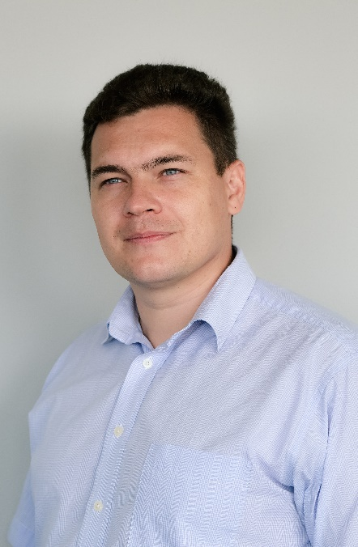**Name and surname:** Oleksii Lyulyov

**Age:** 38 years

**Gender:** male

**The sending university:** Sumy State University, Ukraine

**Country of Mobility:** Latvia

**Host university**: EKA University of Applied Sciences, Pernavas iela 62, Riga, LV-1009, Latvia

**Field of study:** Economics

**Duration of the mobility period:** April 18-24, 2023

**The purpose of the mobility** was to participate in the International Academic Week 2023 at EKA University of Applied Sciences and deliver a lecture on "Bibliometric analysis: instruments and core stages, principles and instruments."

I was thrilled to be a participant in the International Academic Week (IAW2023) hosted by the EKA University of Applied Sciences in Latvia. As someone who is passionate about global collaboration and learning, I was excited to engage with experts and peers from around the world and deepen my knowledge and skills in various fields.

One of the highlights of the week for me were the workshops, where I had the opportunity to learn from experienced professionals and engage in lively discussions with other attendees. The workshop provided valuable insights and practical tips that I can apply to my work, and the collaborative atmosphere was inspiring.

I also enjoyed attending the lectures on various topics related to the university's areas of expertise. The speakers were knowledgeable and engaging, and I learned a lot from their presentations.

The guided tour of Riga was a wonderful way to explore the city and learn more about its rich cultural heritage. Our guide was knowledgeable and enthusiastic, and I came away with a deeper appreciation of the city's history and architecture.

Finally, the meeting with the EKA administration was a valuable opportunity to learn more about the university's vision and strategy, and to discuss potential areas of collaboration and partnership. The administration was welcoming and open to feedback, and I felt that my opinions were valued.

Overall, the International Academic Week at the EKA University of Applied Sciences was an enriching and inspiring experience for me. I am grateful for the opportunity to have participated and look forward to staying in touch with the connections I made during the week.

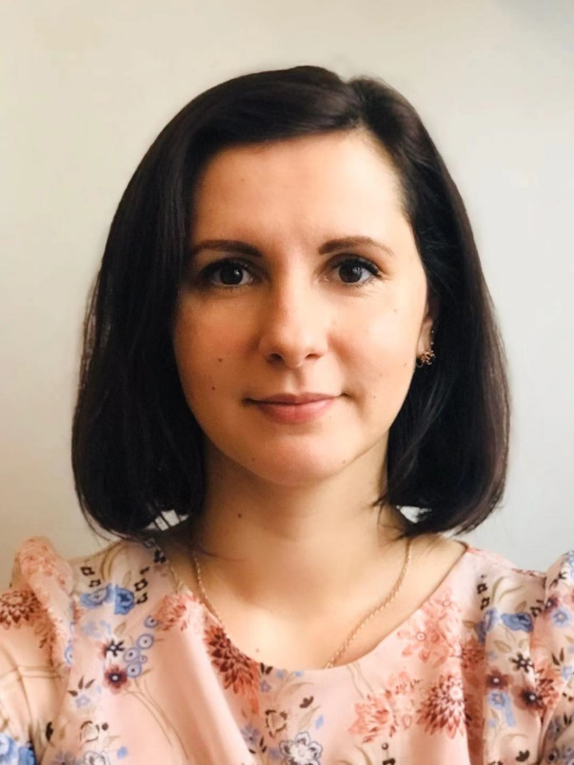

**Name and surname:** Liliia Liulova

**Age:** 36 years

**Gender:** female

**The sending university:** Sumy State University, Ukraine

**Country of Mobility:** Latvia

**Host university**: EKA University of Applied Sciences, Pernavas iela 62, Riga, LV-1009, Latvia

**Field of study:** Economics

**Duration of the mobility period:** April 18-24, 2023

The Erasmus+ mobility program provided me with a fantastic opportunity to take part in the International Academic Week (IAW2023) hosted by the EKA University of Applied Sciences in Latvia. Through this program, I was able to learn from experts from various parts of the world and develop my skills in different fields, such as marketing, digital art, data analysis, etc.

The most valuable outcome of the program for me was the workshops, which covered diverse topics such as the nexus of business and art in research and entrepreneurship, storytelling and gamification in cultural events and marketing, and the application of artificial intelligence in the study process and research. These sessions were interactive and led by experienced professionals, fostering engaging discussions and providing me with practical insights and tips that I can apply to my work.

Additionally, I attended lectures that were directly related to my field of investigation, where the speakers were knowledgeable and engaging, and I learned a lot from their presentations.

Furthermore, during the meeting with the EKA educators, we discussed how to prepare an excellent course description that I will use in my teaching activities, which was very helpful.

Participating in the guided tour of Riga was another highlight of the program, providing me with an opportunity to explore the city and learn about its rich cultural heritage. Our guide was enthusiastic and well-informed, making the experience both enjoyable and educational.

Overall, the mobility program and the International Academic Week at the EKA University of Applied Sciences allowed me to broaden my horizons and make valuable connections. I am grateful for the opportunity.