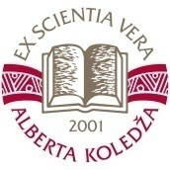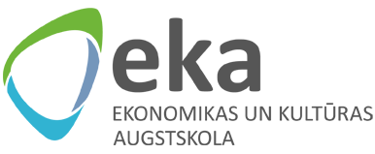

**STAFF TRAINING WEEK 2017 (STW 2017)**

**E-LEARNING: THEORY AND PRACTICE FOR BEGINNERS**

**September 26-29, 2017**

**VENUE:**

**The University College of Economics and Culture (EKA),** Lomonosova Str. 1/5, Riga, LV1019, Latvia

**Alberta College (AK),** Skolas Str. 22, Riga, LV1010, Latvia

**SEPTEMBER 26, 2017 (EKA)**

10:00 – 10:30 Registration, Welcome coffee

10:30 – 10:45 Welcome and presentation of the University of Economics and Culture

10:45 – 11:00 Welcome and presentation of Alberta College

11:00 – 12:30 Presentation of participant institutions

12:30 – 13:30 Lunch

13:30 – 14:30 Presentation of participant institutions

14:30 – 16:00 Ice-breaking activities

18:00 – 20:00 Welcome party (Semarah Hotel Metropole, Aspazijas Boulevard 36/38, Riga)

|  |
| --- |
| **SEPTEMBER 27, 2017 (Alberta College)** |

10:00 – 10:30 Welcome coffee at Alberta College

10:30 – 11:00 Introduction to e-learning

11:00 – 12:30 Introduction to Moodle

12:30 – 13:30 Lunch

13:30 – 14:30 E-learning & e-teaching: methodological aspects

15:00 – 16:00 Visit to National Library of Latvia

|  |
| --- |
| **SEPTEMBER 28, 2017 (EKA)** |

10:00 – 11:30 E-Course development: tutorial

11:30 – 12:00 Coffee break

12:00 – 12:30 Introduction to BigBlueButton (Kaspar)

12:30 – 13:30 Webinar development and e-lecturing workshop (Kaspar)

13:30 – 14:30 Lunch

14:30 – 16:00 E-Course development workshop

18:00 – … Dinner (Semarah Hotel Metropole, Aspazijas Boulevard 36/38, Riga)

|  |
| --- |
| **SEPTEMBER 29, 2017 (EKA)** |

10:00 – 11:00 Individual work in Moodle with mentor assistance

11:00 – 11:30 Coffee break

11:30 – 13:00 Presentation of individual work results

13:00 – 14:00 Lunch

14:00 – 15:00 Presentation of individual work results

15:00 – 16:00 STW2017 Closing ceremony

**CONTACT INFORMATION**

Jeļena Titko, e-mail: [jelena.titko@eka.edu.lv](mailto:jelena.titko@eka.edu.lv) phone: (+371) 29192678